

***Operating Lease Support System Phase-2 Project***

***for***

****

***Functional Specification***

***FC.AE.1.3***

***Manage Warning Letter***

Revision 0.1

**PT. Berlian Sistem Informasi**

KTB Annex Bld. 4th Floor, Jl. Jend. A. Yani. Pulomas,

Tel. +62 21 4786 7575 (Hunting) Fax. +62 21 4714964 www.bsi.co.id

Document Control

|  |  |
| --- | --- |
| **Author** | Amal Hamzah |
| **File Name** |  |
| **Directory Address** |  |
| **Number of Page** |  |

Revision History

|  |  |  |  |
| --- | --- | --- | --- |
| **Date** | **Revision** | **Description** | **Author** |
| 16/11/2015 | 0.0 | Initialization | Amal Hamzah |
| 11/01/2015 | 0.1 | Changes:   * Changing Mr. Jin Nishimura to Mr. Yutaro Sanada as DSF Project Director on Distribution List (page #2) and Document Approval (page #3) * Changing MM/dd/YYYY to MM/dd/yyyy on Period of RPT.AE.1.4 Warning Letter History (page #34) | Amal Hamzah |
|  |  |  |  |

Distribution List

|  |  |  |
| --- | --- | --- |
| Name | Organization | Roles |
| Mr. Yutaro Sanada | Dipo Star Finance, PT | DSF Project Director |
| Mr. Shinji Hosokawa | Dipo Star Finance, PT | DSF Project Advisor |
| Mr. Ahmad Fikri | Dipo Star Finance, PT | DSF Project Advisor |
| Mr. Abdul Somad | Dipo Star Finance, PT | DSF Project Manager |
| Mr. Delta Riangga | Dipo Star Finance, PT | DSF Key User |
| Mr. Mochamad Idris | Dipo Star Finance, PT | DSF Key User |
| Mrs. Herni Hembang | Dipo Star Finance, PT | DSF Key User |
| Mr. Junaidi Didy | Dipo Star Finance, PT | DSF Key User |
| Mr. Dedi Supriyadi | Dipo Star Finance, PT | DSF Key User |
| Mrs. Elke Hilviana | Dipo Star Finance, PT | DSF Key User |
| Mr. Mukhlis Ibrahim | Dipo Star Finance, PT | DSF IT Department Representative |
| Mr. Roby Wijaya | Dipo Star Finance, PT | DSF IT Department Representative |
| Mr. Daiki Kamada | Berlian Sistem Informasi, PT | BSI Project Director |
| Mr. Feri Irawan | Berlian Sistem Informasi, PT | BSI Project Advisor |
| Mr. Grand Zah Putra | Berlian Sistem Informasi, PT | BSI Project Manager |
| Mr. Amal Hamzah | Berlian Sistem Informasi, PT | BSI Business Analyst |

Document Approval

By signing this document I acknowledge I have read the document and give the Project Management Team approval to proceed.

|  |  |  |  |
| --- | --- | --- | --- |
| Role | Name | Signature | Date |
| DSF Project Director | Mr. Yutaro Sanada |  |  |
| DSF Project Advisor | Mr. Ahmad Fikri |  |  |
| DSF Project Manager | Mr. Abdul Somad |  |  |
| DSF IT Department Representative | Mr. Mukhlis Ibrahim |  |  |
| BSI Project Director | Mr. Daiki Kamada |  |  |
| BSI Project Advisor | Mr. Feri Irawan |  |  |
| BSI Project Manager | Mr. Grand Zah Putra |  |  |
| BSI Business Analyst | Mr. Amal Hamzah |  |  |

Table of Contents

Document Control 2

Revision History 2

Distribution List 3

Document Approval 4

1 Introduction 6

1.1 Purpose 6

1.2 Scope 6

1.3 Definition, Acronyms, and Abbreviations 6

1.4 References 7

2 Configuration 7

3 Specification Detail: FC.AE.1.3 Manage Warning Letter 7

3.1 Purpose 7

3.2 Screen of Configuration Access 7

3.3 Screen Functionality 8

3.4 Operation Flow 8

3.5 Screen Design 10

3.6 Component Screen Functionality 19

3.7 Operation Description 21

3.8 Data Structure 30

3.9 Screen Item List 32

3.10 Entity Relationship Diagram 36

* 1. Introduction
  2. Purpose

Functional Specification is a document to describe the detail of functions system which includes screen design and logic formula. This document will be used for system development.

* 1. Scope

Functional Specification Document contains screen design, screen functionality, process flow, and data structure of AE.1.3 Manage Warning Letter

Here are the scopes for AE.1.3 Manage Warning Letter:

1. **AE.1.3.1 Create Warning Letter**

To create new Warning Letter for agreement which has already overdue billing.

1. **AE.1.3.2 Print Warning Letter**

To print Warning Letter and convert to PDF/excel for every warning letter that already created.

1. **AE.1.3.3 Monitor Warning Letter Approval**

To monitor Warning Letter approval process starting from Draft, Submitted, Revised, Rejected, Checked and Approved.

1. **AE.1.3.4 Edit Warning Letter**

To edit existing Warning Letter when warning letter status is Draft and Revised.

Output from this functions is:

1. RPT.AE.1.4 List of Warning Letter report
2. PF.AE.1.4 Warning Letter
   1. Definition, Acronyms, and Abbreviations
3. OPL = Operating Lease
4. TOP = Term Of Payment
5. RAL = Return Authorization Letter (Surat Kuasa Penarikan Unit)
6. BAST = Berita Acara Serah Terima (Handover Report)
7. DSF = Dipo Star Finance
8. HO = Head Office
9. HOB = Head of Branch
10. HOD = Head of Department
11. PIC = Person in Charge
12. Receipt = Kwitansi
13. Notification Letter (Surat Pemberitahuan)
14. Warning Letter (Surat Peringatan)
    1. References

This functional specification document refers to **“To Be Design” BSI Billing Collection Process**, module:

1. AE.1.3 Manage Warning Letter
   1. Configuration

Here will be described the format of Warning Letter document which will be generated when PIC Collection click Save as Draft button. The format of this document number is:

No. Warning Letter : 00001/SP/COL-OPL/CABANG/MONTH/YEAR

Description:

* The first 5 digits show the sequence number of the Warning Letter documents. These numbers will increments whenever new Warning Letter documents is created.
* The code on 3 digits for “SP/COL-OPL” represents Warning Letter
* The code ‘CABANG’ will be substituted by OPL Branch’s code
* The code ‘MONTH’ will be substituted by 2 digits of month when the document created.
* The code ‘YEAR’ will be substituted by 4 digits of year when the document is created.
  1. Specification Detail: FC.AE.1.3 Manage Warning Letter
  2. Purpose

Screen of Manage Warning Letter will be used by PIC Collection to manage Warning Letter. This screen functions consist List of Warning Letter, Create Warning Letter, Edit Warning Letter, Warning Letter Status Approval and Print Warning Letter.

This function covered by **“Manage Warning Letter”** screen

* 1. Screen of Configuration Access

Here are the access rights for **“Manage Warning Letter”** screen users:

|  |  |  |  |  |  |
| --- | --- | --- | --- | --- | --- |
| ***User*** | ***Create*** | ***Read*** | ***Update*** | ***Print*** | **Authorization** |
| PIC Collection | v | v | v | v | v |
| Admin | v | v | v | v | v |
| Head of Branch | - | v | - | - | - |
| Head of Department | - | v | - | - | - |
| Regional Manager | - | v | - | - | - |
| Advisor | - | v | - | - | - |
| Director | - | v | - | - | - |
| President Director | - | v | - | - | - |
| Shareholder’s Meeting | - | v | - | - | - |

Note:

1. Create: related to creation of Warning Letter
2. Read: related to read display Warning Letter
3. Update: related to update data Warning Letter
4. Print: related to print data Warning Letter
5. Authorization: related to approval process of data Warning Letter
   1. Screen Functionality
6. Display list of Warning Letter
7. Create Warning Letter
8. Edit Warning Letter
9. Print Warning Letter
10. Monitor Warning Letter approval
    1. Operation Flow

Below is operation flow for List of Warning Letter process refer to **To Be Design Document Billing Collection**, AE.1.3. Manage Warning Letter:

|  |  |
| --- | --- |
| **PIC PC** | **Process** |
|  | Billing Payment Schedule Detail  (TB\_BIL\_PayScheduleDetail)  Note:  Source  Output & Input    Warning Letter  (Tb\_BIL\_WarningLetter)  Billing Payment Schedule  (TB\_BIL\_PaySchedule) |

Below is operation flow for Create Warning Letter process refer to **To Be Design Document Billing Collection**, AE.1.3. Manage Warning Letter:

|  |  |
| --- | --- |
| **PIC PC** | **Process** |
|  | Billing Payment Schedule Detail  (TB\_BIL\_PayScheduleDetail)  Note:  Source  Output & Input    Warning Letter  (Tb\_BIL\_WarningLetter)  Billing Payment Schedule  (TB\_BIL\_PaySchedule) |

Below is operation flow for Edit Warning Letter process refer to **To Be Design Document Billing Collection**, AE.1.3. Manage Warning Letter:

|  |  |
| --- | --- |
| **PIC PC** | **Process** |
|  | Billing Payment Schedule Detail  (TB\_BIL\_PayScheduleDetail)  Note:  Source  Output & Input    Warning Letter  (Tb\_BIL\_WarningLetter)  Billing Payment Schedule  (TB\_BIL\_PaySchedule) |

* 1. Screen Design
* *Initial Screen List of Warning Letter*

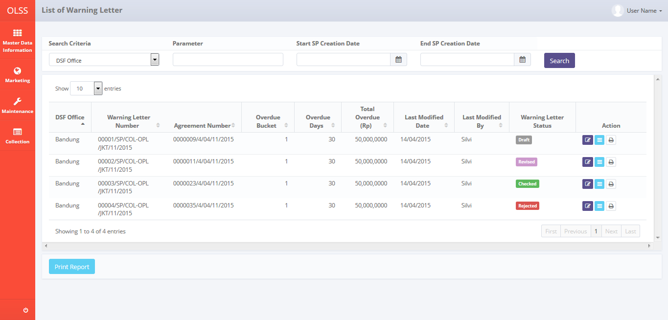

*Screen 1. List of Warning Letter*

* *Screen Design of Create Warning Letter*

*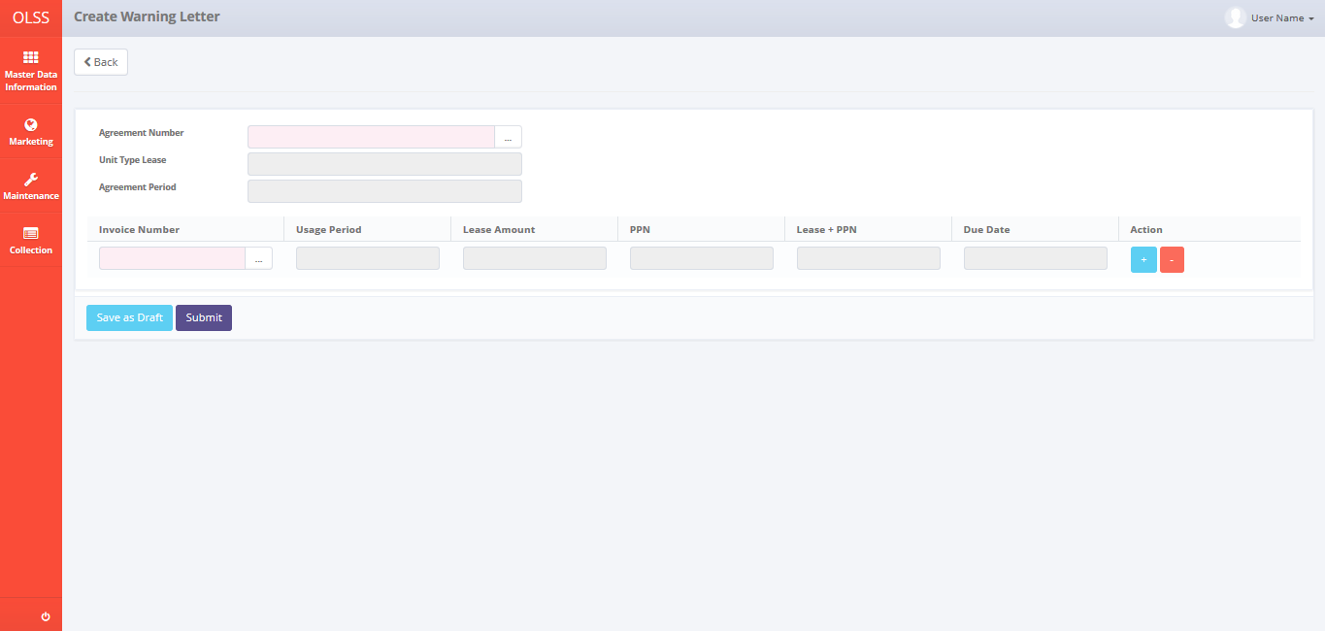*

*Screen 2. Create Warning Letter*

* *Screen Design of Edit Warning Letter*

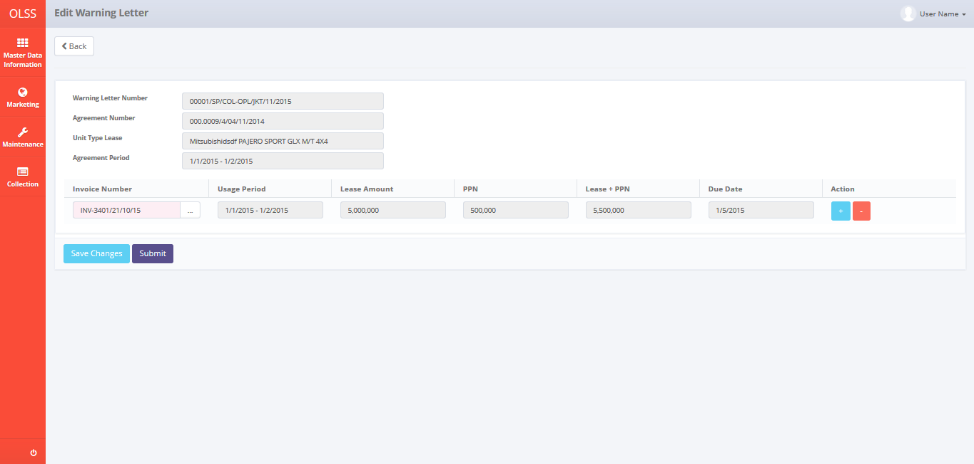

*Screen 3. Edit Warning Letter*

* *Screen Design of Warning Letter Approval Status*

*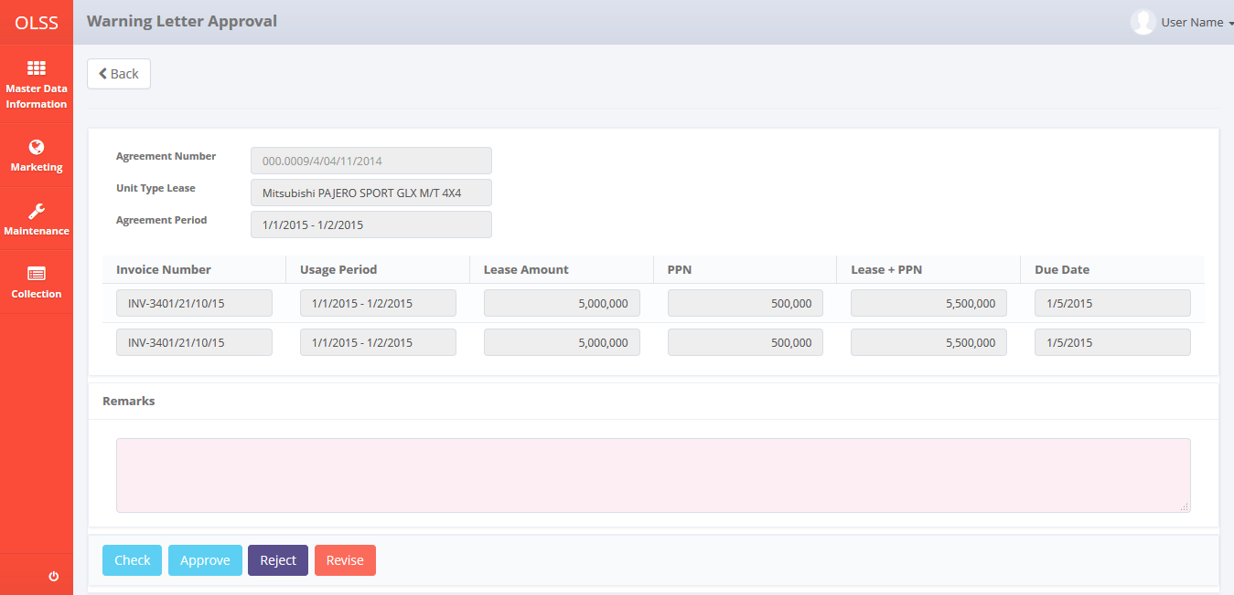*

*Screen 4. Warning Letter Approval Status*

* *Screen Design of Select Agreement Data Pop Up Screen*

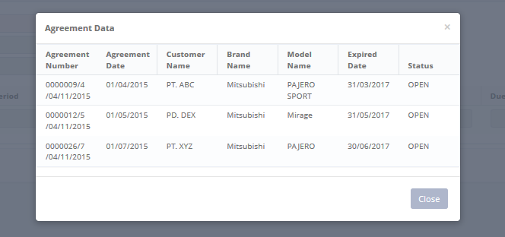

*Screen 5. Select Agreement Data*

* *Screen Design of Select Invoice Data Pop Up Screen*

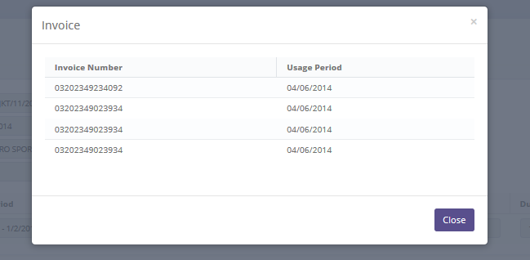

*Screen 6. Select Invoice Data*

* *Screen Design of Print View Warning Letter*

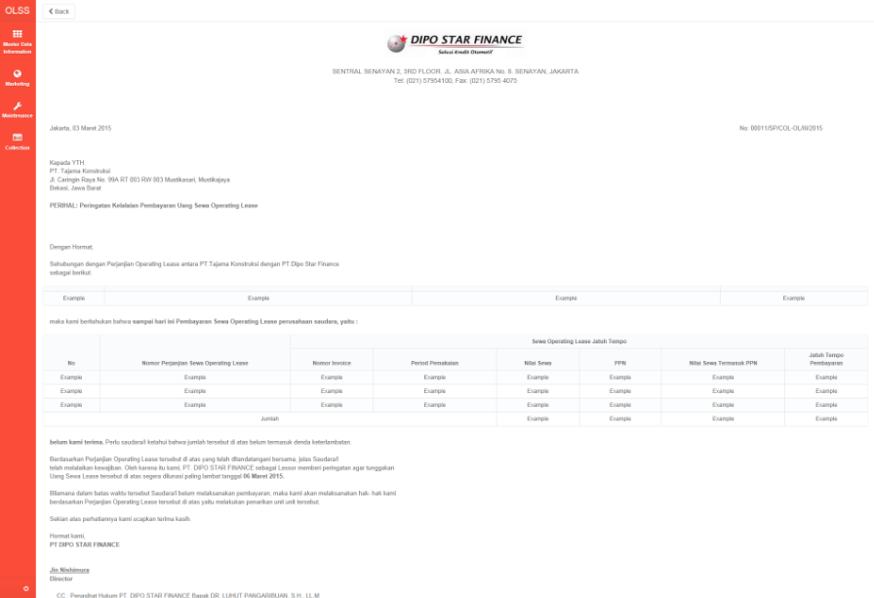

*Screen 7. Print View Warning Letter*

* *Confirmation Pop Up Screen before click button Save as Draft of Warning Letter*

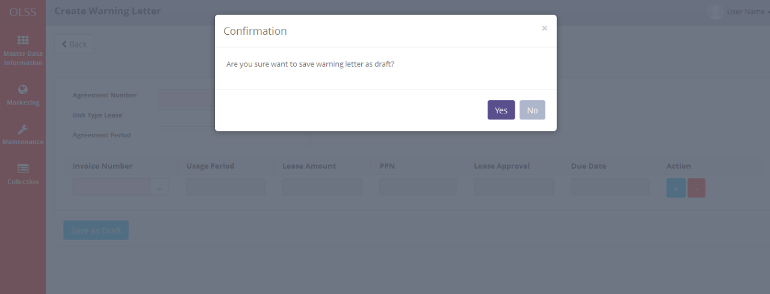

* *Notification Pop Up when Save as Draft of Warning Letter*

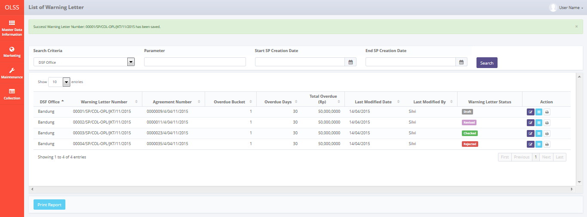

* *Confirmation Pop Up Screen before click button Submit Warning Letter*

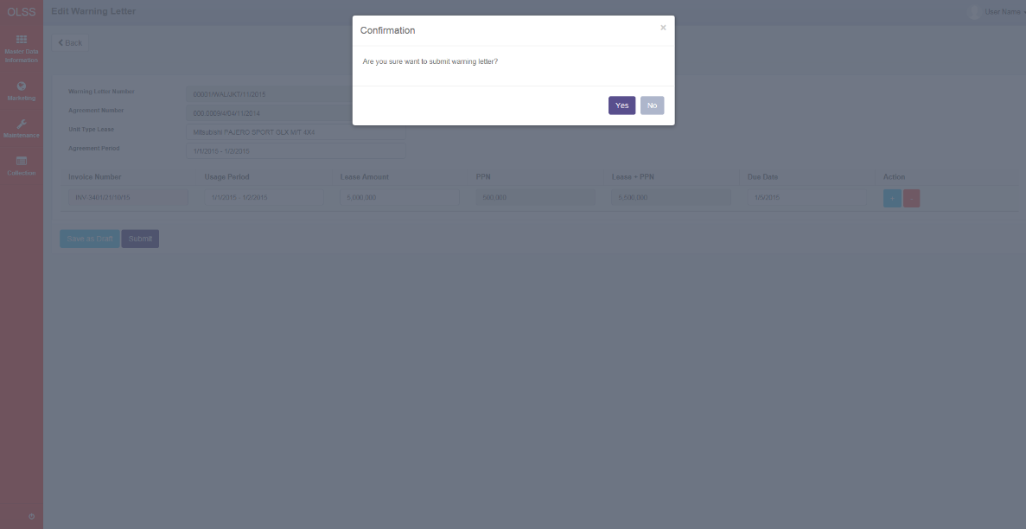

* *Notification Pop Up when Submit of Warning Letter*

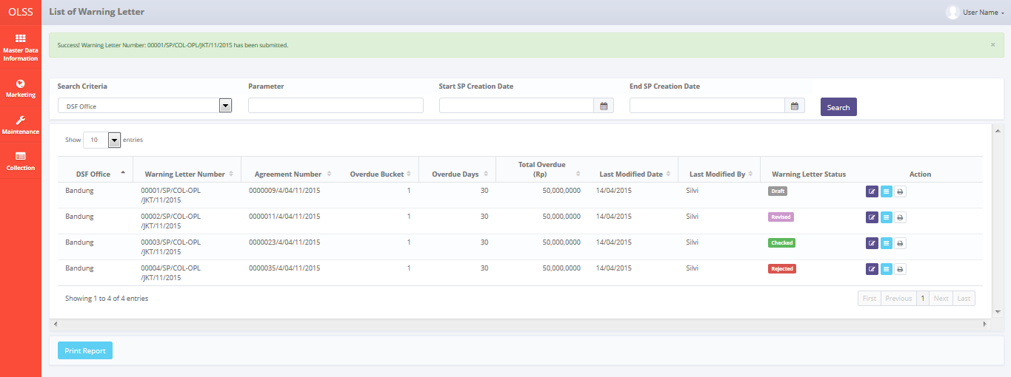

* *Confirmation Pop Up Screen before click button Revise Warning Letter*

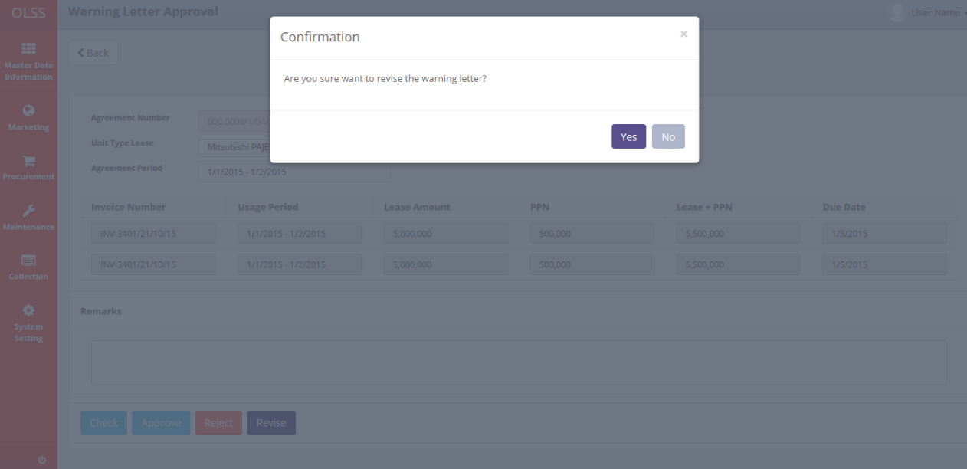

* *Notification Pop Up when Revise of Warning Letter*

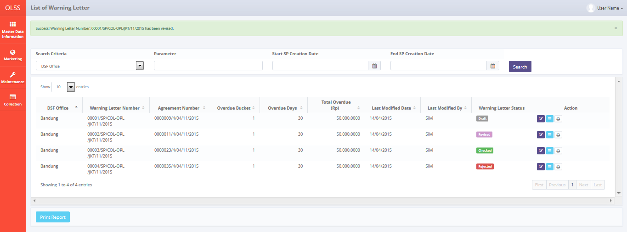

* *Confirmation Pop Up Screen before click button Reject of Warning Letter*

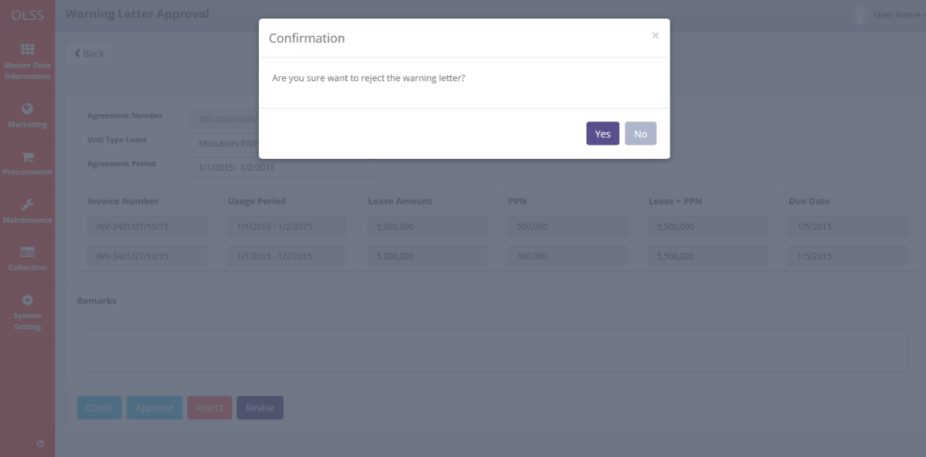

* *Notification Pop Up when Reject of Warning Letter*

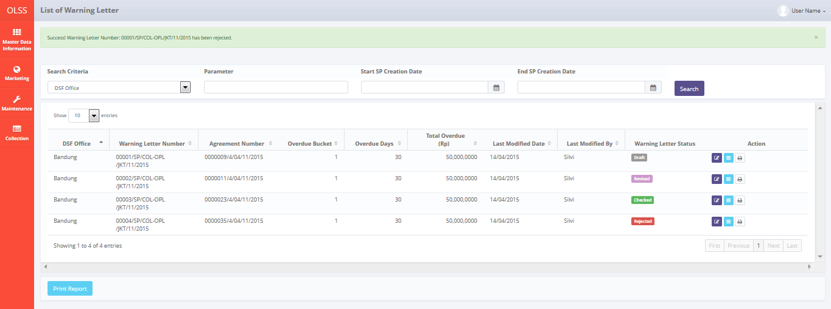

* *Confirmation Pop Up Screen before click button Check of Warning Letter*

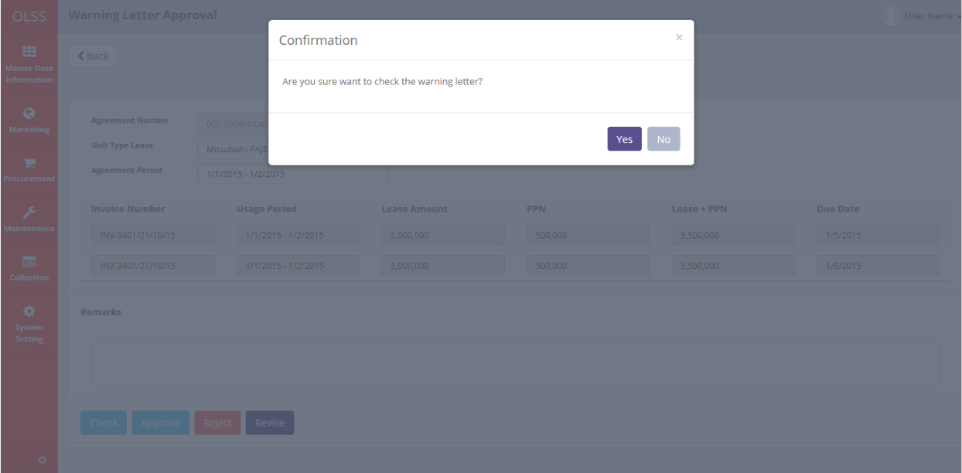

* *Notification Pop Up when Check of Warning Letter*

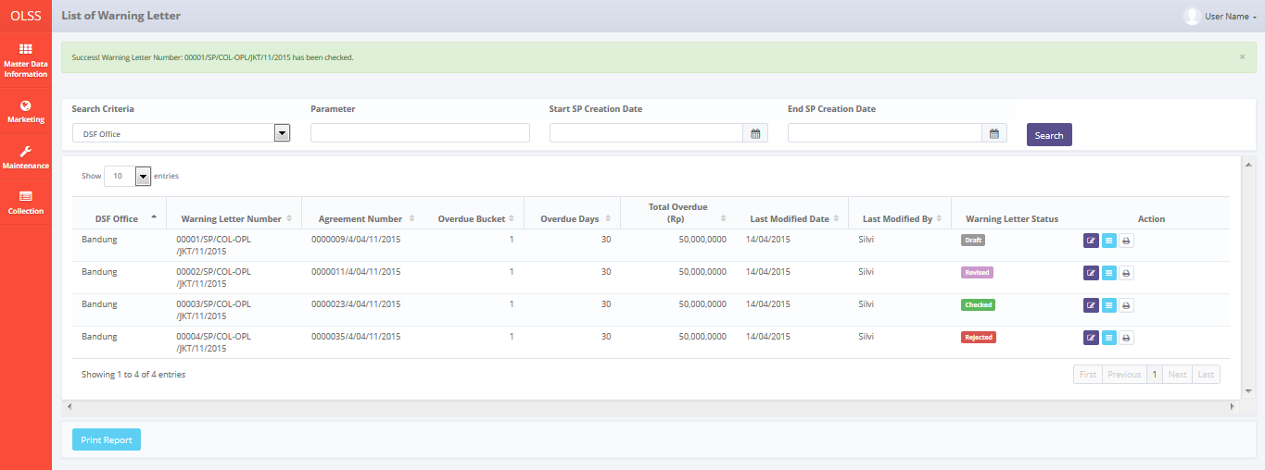

* *Confirmation Pop Up Screen before click button Approve of Warning Letter*

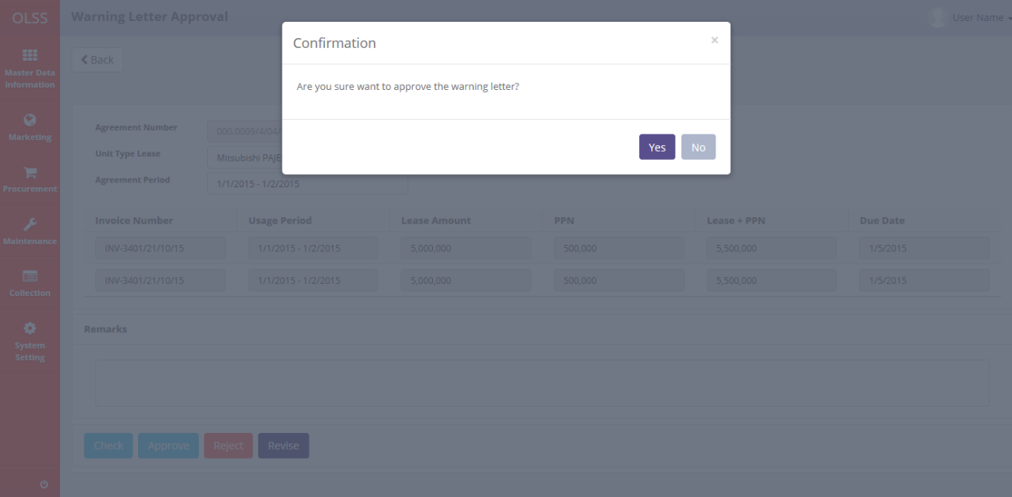

* *Notification Pop Up when Approve of Warning Letter*

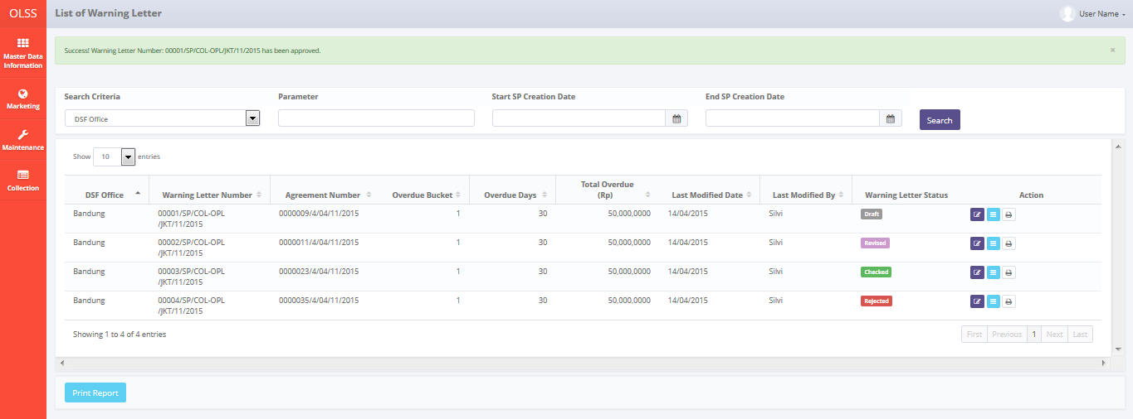

* 1. Component Screen Functionality

Here are the screen functions from each component in Manage Warning Letter screen:

|  |  |  |  |
| --- | --- | --- | --- |
| ***No*** | ***Component*** | ***Name*** | ***Function*** |
| **Header** | | | |
| 1 | Label | List of Warning Letter | List of Warning Letter Title |
| **Search Criteria** | | | |
| 2 | Drop down | Search Criteria | To select category for searching warning letter data |
| 3 | Text Field | Parameter | To input parameter for searching warning letter data |
| 4 | Date Picker | Start SP Creation Date | To input start Warning Letter date based creation of Warning Letter data report |
| 5 | Date Picker | End SP Creation Date | To input end Warning Letter date based on creation of Warning Letter data report |
| 6 | Button | Search | To search warning letter data based on selected criteria |
| **List of Agreements** | | | |
| 7 | Drop down | Show Entries | To select number of row data that will be displayed in one screen (paging) |
| 8 | Button | Print Report | To print report warning letter as shown on the list |
| 9 | Button | Sort | To sort data on table list of warning letter ascending and descending |
| 10 | Label | DSF Office | To display branch of DSF office |
| 11 | Label | Warning Letter Number | To display Warning Letter number |
| 12 | Label | Agreement Number | To display Agreement number |
| 13 | Label | Overdue Bucket | To display overdue bucket |
| 14 | Label | Overdue Days | To display overdue days |
| 15 | Label | Total Overdue (Rp) | To display total overdue amount in IDR |
| 16 | Label | Last Modified Date | To display last modification date of warning letter |
| 17 | Label | Last Modified By | To display user name who last modification the warning letter |
| 18 | Label | Warning Letter Status | To display lastest status the warning letter |
| 19 | Button | Edit Warning Letter | To edit warning letter |
| 20 | Button | View Warning Letter | To view warning letter aproval |
| 21 | Button | Print Warning Letter | To print warning letter |
| 22 | Label | Showing N to M of X entries | Displaying agreement data sequence and the total of warning letter data |
| 23 | Button | First Page | To display first entries page of warning letter data |
| 24 | Button | Previous Page | To display the previous entries page of warning letter data |
| 25 | Button | Page Number | Displaying the page number of the list |
| 26 | Button | Next Page | To display the next entries page of warning letter data |
| 27 | Button | Last Page | To display the last entries page of warning letter data |

* 1. Operation Description

|  |  |  |
| --- | --- | --- |
| **No.** | **Operation Name** | **Description** |
| 1 | Initial view of List of Warning Letter | The screen of list of Warning Letter:   * 1. Component Status;  |  |  |  |  | | --- | --- | --- | --- | | Component | Name/Caption | Status | Remark | | Label | List of Warning Letter | Not Active |  | | Drop down box | Search criteria category | Active | As initial by default column name that will be display on drop down is DSF Office | | Text box | Search criteria value | Active |  | | Label | DSF Office | Not Active |  | | Label | Warning Letter Number | Not Active |  | | Label | Agreement Number | Not Active |  | | Label | Overdue Bucket | Not Active |  | | Label | Overdue Days | Not Active |  | | Label | Total Overdue (Rp) | Not Active |  | | Label | Last Modified Date | Not Active |  | | Label | Last Modified By | Not Active |  | | Label | Warning Letter Status | Not Active |  | | Label | Action | Not Active |  | | Button | Edit Warning Letter | Active |  | | Button | View Warning Letter | Active |  | | Button | Print Warning Letter | Active |  | | Button | First Page | Active | Active depending on the current entry | | Button | Previous Page | Active | Active depending on the current entry | | Link | Page Number | Active | Active depending on the current entry | | Button | Next Page | Active | Active depending on the current entry | | Button | Last Page | Active | Active depending on the current entry | |
| 2 | Searching the List of Warning Letter | Input:   1. Select searching criteria category (search criteria), searching criteria value (parameter), Start SP Date and End SP Date in search field       Constraint:   1. Search criteria only consists of DSF Office, Warning Letter Number, Agreeement Number, Agreement Date, Overdue Bucket, Overdue Days, Total Overdue (Rp), Last Modified Date, Last Modified By and Warning Letter Status (the same as the lists) generated from Tb\_OPL\_SearchCriteria mapping 2. End SP Creation Date can not be less than Start SP Creation Date (the End SP Creation Date will be locked for the date before Start SP Creation Date) 3. Start SP Creation Date can not be more than End SP Creation Date (the Start SP Creation Date will be locked for the date after End SP Creation Date) 4. Click on the Search Button     Process:   1. The screen will view the list of agreement according to criteria 2. Based on **Screen 1. List of Warning Letter**, information related to Warning Letter that will be display automatically are:  * DSF Office * Warning Letter Number * Agreement Number * Overdue Bucket * Overdue Days * Total Overdue (Rp) * Last Modified Date * Last Modified By * Warning Letter Status  1. Number data row on list will be based on selected show number entries 2. Select number of show list entries: 10, 25, 50, and 100 and click the page for viewing more data 3. Default view will display data list of warning letter which already created. 4. After click the Search button, the system will get data from Tb\_BIL\_WarningLetter table to be displayed in the list. 5. Warning Letter data will displays sorted descending base on Warning Letter Creation Date, DSF Office, Warning Letter Number and Agreement Number.   Output:  N/A |
| 3 | Edit Warning Letter | Input:   1. Access menu OLSS 2. Hover to menu Collection 3. Click on monitor overdue sub menu 4. Click Manage Warning Letter button      1. Click button Edit Warning Letter on row to edit specific   Process:   1. View data of Agreement Overdue:  |  |  | | --- | --- | | **Agreement Data** | **Constraint Input** | | Warning Letter Number | Varchar | | Agreement Number | Varchar | | Unit Type Lease | Varchar | | Agreement Period | Varchar |  1. Add or remove list data of Invoice overdue:  |  |  | | --- | --- | | **Invoice Data** | **Constraint Input** | | Invoice Number | Varchar | | Usage Period | Datetime | | Lease Amount | Decimal | | PPN | Decimal | | Lease + PPN | Decimal | | Due Date | Datetime |   Constraints:   1. Agreement Data will display in accordance the clicked list data 2. All invoice data refer to Agreement Number above 3. All data are view only, not editable 4. Click button  to add row of invoice 5. When add data, will display new line of invoice data below contain of:  |  |  | | --- | --- | | **Invoice Data** | **Constraint Input** | | Invoice Number | Varchar | | Usage Period | Datetime | | Lease Amount | Decimal | | PPN | Decimal | | Lease + PPN | Decimal | | Due Date | Datetime |     Constraint:   1. The editable data is Invoice Number which input value is List of Value (LOV) 2. When button  is clicked will display pop up screen of Invoice Data base on displayed Agreement Number.      1. Select the desired invoice to input to warning letter data 2. Selected invoice data will appear on warning letter edit screen 3. On selected row, Invoice Number, Usage Period, Lease Amount, PPN, Lease Amount + PPN and due date will automatically filled depends on selected invoice. 4. All data list are disabled, except Invoice Number. 5. If Invoice Number is empty then display hint “Invoice Number is required”. 6. Click button  to remove current row of invoice 7. When user already edit data but want to edit later, then click on button Save Changes to save data.      1. When button Save Changes clicked, then confirmation dialog at screen 3 ‘Are you sure you want to save as changes?’ message will be displayed. 2. User can click on Yes button to confirm the changes or click on No button to go back to edit Warning Letter screen.   Constraint:   1. If clicked with any of the field still hasn’t meet the validation criteria, every notification message for validation below the field will be generated after user click Yes button. 2. When User want to proceed to Warning Letter approval, user can click on button Submit.      1. When user click submit button, confirmation dialog at screen 3 ‘Are you sure you want to submit?’ message will be displayed.   Constraint:   1. If clicked with any of the field still hasn’t meet the validation criteria, every notification message for validation below the field will be generated after user click Yes button. 2. Edit Warning Letter only enable for Warning Letter data with status on **draft** or **revised**. 3. When Save Changes button is clicked, System will add a new log of Warning Letter action to TB\_BIL\_WarningLetter\_History. Data which should be inserted are:  |  |  | | --- | --- | | **Field Name** | **Value** | | ProcessId | New GUID | | OriginalId | TB\_BIL\_WarningLetter | | CreatedDate | Sys.CurrentDate | | CreatedBy | User.UserName | | Action | TB\_OPL\_Status.StatusCode = DRAFT |  1. When Submit button is clicked, System will add a new log of Warning Letter action to TB\_BIL\_WarningLetter\_History. Data which should be inserted are:  |  |  | | --- | --- | | **Field Name** | **Value** | | ProcessId | New GUID | | OriginalId | TB\_BIL\_WarningLetter | | CreatedDate | Sys.CurrentDate | | CreatedBy | User.UserName | | Action | TB\_OPL\_Status.StatusCode = SUBMITTED |  1. When Revise button is clicked, System will add a new log of Warning Letter action to TB\_BIL\_WarningLetter\_History. Data which should be inserted are:  |  |  | | --- | --- | | **Field Name** | **Value** | | ProcessId | New GUID | | OriginalId | TB\_BIL\_WarningLetter | | CreatedDate | Sys.CurrentDate | | CreatedBy | User.UserName | | Action | TB\_OPL\_Status.StatusCode = REVISED |  1. When Reject button is clicked, System will add a new log of Warning Letter action to TB\_BIL\_WarningLetter\_History. Data which should be inserted are:  |  |  | | --- | --- | | **Field Name** | **Value** | | ProcessId | New GUID | | OriginalId | TB\_BIL\_WarningLetter | | CreatedDate | Sys.CurrentDate | | CreatedBy | User.UserName | | Action | TB\_OPL\_Status.StatusCode = REJECTED |  1. When Check button is clicked, System will add a new log of Warning Letter action to TB\_BIL\_WarningLetter\_History. Data which should be inserted are:  |  |  | | --- | --- | | **Field Name** | **Value** | | ProcessId | New GUID | | OriginalId | TB\_BIL\_WarningLetter | | CreatedDate | Sys.CurrentDate | | CreatedBy | User.UserName | | Action | TB\_OPL\_Status.StatusCode = CHECKED |  1. When Approve button is clicked, System will add a new log of Warning Letter action to TB\_BIL\_WarningLetter\_History. Data which should be inserted are:  |  |  | | --- | --- | | **Field Name** | **Value** | | ProcessId | New GUID | | OriginalId | TB\_BIL\_WarningLetter | | CreatedDate | Sys.CurrentDate | | CreatedBy | User.UserName | | Action | TB\_OPL\_Status.StatusCode = APPROVED |   Output:   1. The row of edited Warning Letter data at list of Warning Letter screen will be change. 2. Display success message on top of List of Warning Letter when Warning Letter data has been submitted or save changes successfully:   “Success! Warning Letter Number: 10000/SP/COL-OPL/SBY/11/2015 has been successfully updated/submitted”  Alternative:  N/A |
| 4 | Create Warning Letter | Input:   1. Access menu OLSS 2. Hover to menu Collection 3. Click on monitor overdue sub menu 4. Click button Create Warning Letter on row to create Warning Letter base on selected Agreement Number   Process:   1. View data of Agreement Overdue:  |  |  | | --- | --- | | **Agreement Data** | **Constraint Input** | | Agreement Number | Varchar | | Unit Type Lease | Varchar | | Agreement Period | Varchar |  1. Add or remove list data of Invoice overdue:  |  |  | | --- | --- | | **Invoice Data** | **Constraint Input** | | Invoice Number | Varchar | | Usage Period | Datetime | | Lease Amount | Decimal | | PPN | Decimal | | Lease + PPN | Decimal | | Due Date | Datetime |   Constraints:   1. Agreement Data will display in accordance the clicked list data 2. All invoice data refer to Agreement Number above 3. All data are view only, not editable 4. Click button  to add row of invoice 5. When add data, will display new line of invoice data below contain of:  |  |  | | --- | --- | | **Invoice Data** | **Constraint Input** | | Invoice Number | Varchar | | Usage Period | Datetime | | Lease Amount | Decimal | | PPN | Decimal | | Lease + PPN | Decimal | | Due Date | Datetime |     Constraint:   1. The editable data is Invoice Number which input value is List of Value (LOV) 2. When button  is clicked will display pop up screen of Invoice Data base on displayed Agreement Number.      1. Select the desired invoice to input to warning letter data 2. Selected invoice data will appear on warning letter edit screen 3. Click button  to remove current row of invoice 4. Click button Save as Draft to save data      1. When button Save as Draft clicked, then confirmation dialog at screen 3 ‘Are you sure you want to save as changes?’ message will be displayed. 2. User can click on Yes button to confirm the changes or click on No button to go back to edit Warning Letter screen.   Constraint:   1. If clicked with any of the field still hasn’t meet the validation criteria, every notification message for validation below the field will be generated after user click Yes button. 2. When User want to proceed to Warning Letter approval, user can click on button Submit.      1. When user click submit button, confirmation dialog at screen 3 ‘Are you sure you want to submit?’ message will be displayed.   Constraint:   1. If clicked with any of the field still hasn’t meet the validation criteria, every notification message for validation below the field will be generated after user click Yes button. 2. When Save as Draft button is clicked, System will add a new log of Warning Letter action to TB\_BIL\_WarningLetter\_History. Data which should be inserted are:  |  |  | | --- | --- | | **Field Name** | **Value** | | ProcessId | New GUID | | OriginalId | TB\_BIL\_WarningLetter | | CreatedDate | Sys.CurrentDate | | CreatedBy | User.UserName | | Action | TB\_OPL\_Status.StatusCode = DRAFT |  1. When Submit button is clicked, System will add a new log of Warning Letter action to TB\_BIL\_WarningLetter\_History. Data which should be inserted are:  |  |  | | --- | --- | | **Field Name** | **Value** | | ProcessId | New GUID | | OriginalId | TB\_BIL\_WarningLetter | | CreatedDate | Sys.CurrentDate | | CreatedBy | User.UserName | | Action | TB\_OPL\_Status.StatusCode = SUBMITTED |  1. When Revise button is clicked, System will add a new log of Warning Letter action to TB\_BIL\_WarningLetter\_History. Data which should be inserted are:  |  |  | | --- | --- | | **Field Name** | **Value** | | ProcessId | New GUID | | OriginalId | TB\_BIL\_WarningLetter | | CreatedDate | Sys.CurrentDate | | CreatedBy | User.UserName | | Action | TB\_OPL\_Status.StatusCode = REVISED |  1. When Reject button is clicked, System will add a new log of Warning Letter action to TB\_BIL\_WarningLetter\_History. Data which should be inserted are:  |  |  | | --- | --- | | **Field Name** | **Value** | | ProcessId | New GUID | | OriginalId | TB\_BIL\_WarningLetter | | CreatedDate | Sys.CurrentDate | | CreatedBy | User.UserName | | Action | TB\_OPL\_Status.StatusCode = REJECTED |  1. When Check button is clicked, System will add a new log of Warning Letter action to TB\_BIL\_WarningLetter\_History. Data which should be inserted are:  |  |  | | --- | --- | | **Field Name** | **Value** | | ProcessId | New GUID | | OriginalId | TB\_BIL\_WarningLetter | | CreatedDate | Sys.CurrentDate | | CreatedBy | User.UserName | | Action | TB\_OPL\_Status.StatusCode = CHECKED |  1. When Approve button is clicked, System will add a new log of Warning Letter action to TB\_BIL\_WarningLetter\_History. Data which should be inserted are:  |  |  | | --- | --- | | **Field Name** | **Value** | | ProcessId | New GUID | | OriginalId | TB\_BIL\_WarningLetter | | CreatedDate | Sys.CurrentDate | | CreatedBy | User.UserName | | Action | TB\_OPL\_Status.StatusCode = APPROVED |   Output:   1. The row of edited Warning Letter data at list of Warning Letter screen will be change. 2. Display success message on top of List of Warning Letter when Warning Letter data has been submitted or save as draft successfully:   “Success! Warning Letter Number: 10000/SP/COL-OPL/SBY/11/2015 has been successfully created/submitted”  Alternative:  N/A |
| 5 | Print Warning Letter | Input:   1. Access menu OLSS 2. Hover to menu Collection 3. Click on Monitor Overdue sub menu 4. Click on button Manage Warning Letter 5. Click on Print icon at the row of List of Warning Letter which Warning Letter Status is **submitted**      1. Click Print button to preview Warning Letter document which will be printed. 2. At print form preview, click print button to print Warning Letter document as a hardcopy.   Process:   1. System will display a preview of Warning Letter document which will be printed. 2. System will convert to Warning Letter document to excel or PDF depends on user choice when user click convert to button. 3. System will print Warning Letter as a hardcopy when user click print button at print form preview, where Warning Letter creation date is taken from WarningLetterIssueDate’s value at TB\_BIL\_WarningLetter table.   Output:   1. A hardcopy, excel or PDF file of Warning Letter document print form.   Alternative:  N/A |
| 6 | Print Report Warning Letter History | Input:   1. Access menu OLSS 2. Hover to menu Collection 3. Click on Monitor Overdue sub menu 4. Click on button Manage Warning Letter 5. Select Search Criteria Drop down box and click among these:  |  |  | | --- | --- | | **Search Criteria** | **Constraint Input** | | DSF Office | Varchar | | Warning Letter | Varchar | | Agreement Number | Varchar | | Overdue Bucket | Integer | | Overdue Days | Integer | | Total Overdue | Decimal | | Created By | Varchar | | Checked By | Varchar | | Approved By | Varchar |   Constraint:   1. Validation of parameter based on the contraint value will be executed when user click search button. 2. Select Start and End date period to filter based on the Agreement date   D:\Users\bsi00815\AppData\Local\Microsoft\Windows\Temporary Internet Files\Content.Word\VCS_List.png  Constraint:   1. Search criteria only consists of DSF Office, Warning Letter Number, Agreeement Number, Agreement Date, Overdue Bucket, Overdue Days, Total Overdue, Created By, Checked By and Approved By (the same as the lists) generated from Tb\_OPL\_SearchCriteria mapping 2. End Warning Letter Created Date can not be less than Start Warning Letter Created Date (the End Warning Letter Created Date will be locked for the date before Start Warning Letter Created Date) 3. Start Warning Letter Created Date can not be more than End Warning Letter Created Date (the Start Warning Letter Created Date will be locked for the date after End Warning Letter Created Date) 4. Click Search button:   D:\Users\bsi00815\AppData\Local\Microsoft\Windows\Temporary Internet Files\Content.Word\Visit Customer Survey Report.png   1. List of data which will be printed will be shown at the list. To print those data as Warning Letter report, user should click Print Report button:     Process:   1. User can view list of Warning Letter data which will be printed, in the Warning Letter search result list. 2. Informations related to Billing that will be printed are:    1. DSF Office    2. Warning Letter Number    3. Agreement Number    4. Overdue Bucket    5. Overdue Days    6. Total Overdue (Rp)    7. Created By    8. Checked By    9. Approved By 3. List of warning letter will be sorted descending by warning letter created date.   Output:   1. Warning Letter Historical Report will be saved as Warning Letter Report\_MMddyyyy\_hhmm, where MMddyyyy and hhmm is the time when button Print Report is clicked. |
| 7 | System Error Message | Process:   1. Any kind of errors out of application validation or cannot be handled by application such as error when communicate with database server, bugs, overloop etc will generate error message:   “System error. Please contact your administrator”  Output:   1. A page with system error message will appear. |

* 1. Data Structure

**TB\_BIL\_WarningLetter**

|  |  |  |  |  |  |  |
| --- | --- | --- | --- | --- | --- | --- |
| *Field Name* | *Data Type* | *Length* | *Source* | *Remarks* | *Nullable* | *Mandatory* |
| IdTb\_BIL\_WarningLetterDetail | *integer* | *N/A* | TB\_BIL\_WarningLetter.IdTB\_BIL\_WarningLetterDetail | ***Primary Key*** | *No* | *Yes* |
| Tb\_BIL\_PayScheduleDetailID | *integer* | *N/A* | TB\_BIL\_PayScheduleDetail.IdTB\_BIL\_PayScheduleDetail | ***Foreign Key*** | *No* | *Yes* |
| WarningLetterNo | *Varchar* | *20* | TB\_BIL\_WarningLetter.WarningLetterNo |  | *No* | *Yes* |
| WarningLetterStatus | *Varchar* | *25* | TB\_BIL\_WarningLetter.WarningLetterStatus |  | *No* | *Yes* |
| WarningLetterIssueDate | *Datetime* | *N/A* | TB\_BIL\_WarningLetter.WarningLetterIssueDate |  | *No* | *Yes* |
| DocumentType | *Varchar* | *25* | TB\_BIL\_WarningLetter.DocumentType |  | *No* | *Yes* |
| ValidUntil | *Datetime* | *N/A* | TB\_BIL\_WarningLetter.ValidUntil |  | *Yes* | *No* |
| Remarks | *Varchar* | *50* | TB\_BIL\_WarningLetter.Remarks |  | *Yes* | *No* |
| CreatedDate | *Datetime* | *N/A* | TB\_BIL\_WarningLetter.CreatedDate |  | *No* | *Yes* |
| CreatedBy | *Varchar* | *50* | TB\_BIL\_WarningLetter.CreatedBy |  | *No* | *Yes* |
| LastModifiedDate | *Datetime* | *N/A* | TB\_BIL\_WarningLetter.LastModifiedDate |  | *Yes* | *No* |
| LastModifiedBy | *Varchar* | *50* | TB\_BIL\_WarningLetter.LastModifiedBy |  | *Yes* | *No* |

**TB\_BIL\_WarningLetter\_History**

|  |  |  |  |  |  |  |
| --- | --- | --- | --- | --- | --- | --- |
| *Field Name* | *Data Type* | *Length* | *Source* | *Remarks* | *Nullable* | *Mandatory* |
| ProcessId | *Varchar* | *N/A* | TB\_BIL\_WarningLetter\_History.ProcessId | ***Primary Key***  *New GUID* | *No* | *Yes* |
| OriginalId | *integer* | *N/A* | TB\_BIL\_WarningLetter\_History.OriginalId | ***Foreign Key*** | *No* | *Yes* |
| CreatedDate | *Datetime* | *N/A* | TB\_BIL\_WarningLetter\_History.CreatedDate |  | *No* | *Yes* |
| CreatedBy | *Varchar* | *25* | TB\_BIL\_WarningLetter\_History.CreatedBy |  | *No* | *Yes* |
| Action | *Varchar* | *100* | TB\_BIL\_WarningLetter\_History.Action |  | *No* | *Yes* |

**TB\_BIL\_WarningLetter\_History\_Dtl**

|  |  |  |  |  |  |  |
| --- | --- | --- | --- | --- | --- | --- |
| *Field Name* | *Data Type* | *Length* | *Source* | *Remarks* | *Nullable* | *Mandatory* |
| ProcessId | *Varchar* | *N/A* | TB\_BIL\_WarningLetter\_History\_Dtl.ProcessId | ***Primary Key***  *New GUID* | *No* | *Yes* |
| WarningLetterNo | *Varchar* | *20* | TB\_BIL\_WarningLetter.WarningLetterNo |  | *No* | *Yes* |
| WarningLetterStatus | *Varchar* | *25* | TB\_BIL\_WarningLetter.WarningLetterStatus |  | *No* | *Yes* |
| WarningLetterIssueDate | *Datetime* | *N/A* | TB\_BIL\_WarningLetter.WarningLetterIssueDate |  | *No* | *Yes* |
| DocumentType | *Varchar* | *25* | TB\_BIL\_WarningLetter.DocumentType |  | *No* | *Yes* |
| ValidUntil | *Datetime* | *N/A* | TB\_BIL\_WarningLetter.ValidUntil |  | *Yes* | *No* |
| Remarks | *Varchar* | *50* | TB\_BIL\_WarningLetter.Remarks |  | *Yes* | *No* |
| CreatedDate | *Datetime* | *N/A* | TB\_BIL\_WarningLetter.CreatedDate |  | *No* | *Yes* |
| CreatedBy | *Varchar* | *50* | TB\_BIL\_WarningLetter.CreatedBy |  | *No* | *Yes* |
| LastModifiedDate | *Datetime* | *N/A* | TB\_BIL\_WarningLetter.LastModifiedDate |  | *Yes* | *No* |
| LastModifiedBy | *Varchar* | *50* | TB\_BIL\_WarningLetter.LastModifiedBy |  | *Yes* | *No* |

* 1. Screen Item List

**PF.AE.1.2 Warning Letter**

|  |  |  |  |  |
| --- | --- | --- | --- | --- |
| *No.* | *Content* | *Description* | *Source* | *Remarks* |
| 1 | Logo | DSF Logo | Embedded |  |
| 2 | Company Address | DSF HO Address | REFF\_OFFICE.OFFICE\_ADDR |  |
| 3 | No Warning Letter | Warning Letter Number | TB\_BIL\_WarningLetter.WarningLetterNumber |  |
| 4 | Tanggal terbit | Warning Letter issue date | TB\_BIL\_WarningLetter.WarningLetterIssueDate | Format display report:  MM/dd/yyyy |
| 5 | Customer Name | Name of customer | Customer.Name |  |
| 6 | Customer Address | Address of customer | Customer.Address |  |
| 7 | Perihal | Perihal: Peringatan Kelalaian Pembayaran Uang Sewa Operating Lease | Static value |  |
| 8 | Dengan Hormat | Dengan Hormat,  Sehubungan denga Perjanjian [customer name] dengan PT. Dipo Star Finance sebagai berikut: | Customer.Name | Other is static value |
| 9 | No | Serial number | Auto generated number |  |
| 10 | Nomor Perjanjian Sewa Operating Lease | Agreement Number | OPLAgreement.AgreementNumber |  |
| 11 | Kendaraan Sewa Operating Lease | Unit Name | Product.ProductName |  |
| 12 | Nilai Sewa Operating Lease per bulan (belum termasuk PPN) | Billing Amount | Tb\_BIL\_PayScheduleDetail.BillingAmt |  |
| 13 | Pembayaran sewa | Maka kami beritahukan bahwa sampai hari ini Pembayaran Sewa Operating Lease perusahaan saudara, yaitu: | Static value |  |
| 14 | No | Serial number | Auto generated number |  |
| 15 | Nomor Perjanjian Operating Lease | Agreement Number | OPLAgreement.AgreementNumber |  |
| 16 | Nomor Invoice | Invoice Number | TB\_BIL\_InvoiceReceipt.InvoiceNo |  |
| 17 | Periode Pemakaian | Usage Unit Period | TB\_BIL\_PayScheduleDetail.PaymentSchedule |  |
| 18 | Nilai Sewa | Billing Amount | TB\_BIL\_PayScheduleDetail.BillingAmt |  |
| 19 | PPN | VAT | TB\_BIL\_PayScheduleDetail.VATAmt |  |
| 20 | Nilai Sewa termasuk PPN | Billing Amount + VAT | TB\_BIL\_PayScheduleDetail.BillingAmt + TB\_BIL\_PayScheduleDetail.VATAmt |  |
| 21 | Jatuh Tempo Pembayaran | Due Date | OPLAgreement.FDueDateUsage |  |
| 22 | Keterangan Pembayaran | belum kami terima. Perlu saudara/i ketahui bahwa jumlah tersebut di atas belum termasuk denda keterlambatan.  Berdasarkan Perjanjian Operating Lease tersebut di atas yang telah ditandatangani bersama, jelas Saudara/i  telah melalaikan kewajiban. Oleh karena itu kami, PT. DIPO STAR FINANCE sebagai Lessor memberi peringatan agar tunggakan  Uang Sewa Lease tersebut di atas segera dilunasi paling lambat tanggal **[Due Date]**.  Bilamana dalam batas waktu tersebut Saudara/i belum melaksanakan pembayaran, maka kami akan melaksanakan hak- hak kami  berdasarkan Perjanjian Operating Lease tersebut di atas yaitu melakukan penarikan unit unit tersebut.  Sekian atas perhatiannya kami ucapkan terima kasih.  Hormat kami, | OPLAgreement.FDueDateUsage | Other is Static value  Format **[due date]**:  DD Month YYYY |
| 23 | PT. Dipo Star Finance | PT. DIPO STAR FINANCE | Static value |  |
| 24 | Nama Direktur | Name of Director | TB\_OPL\_Employee.IdEmployee |  |
| 25 | Direktur | Approval Role | Role.IdRole |  |
| 26 | CC: | CC : Penasihat Hukum PT. DIPO STAR FINANCE Bapak DR. LUHUT PANGARIBUAN, S.H., LL.M | TB\_BIL\_WarningLetter.CCLaywer | Other is static value |

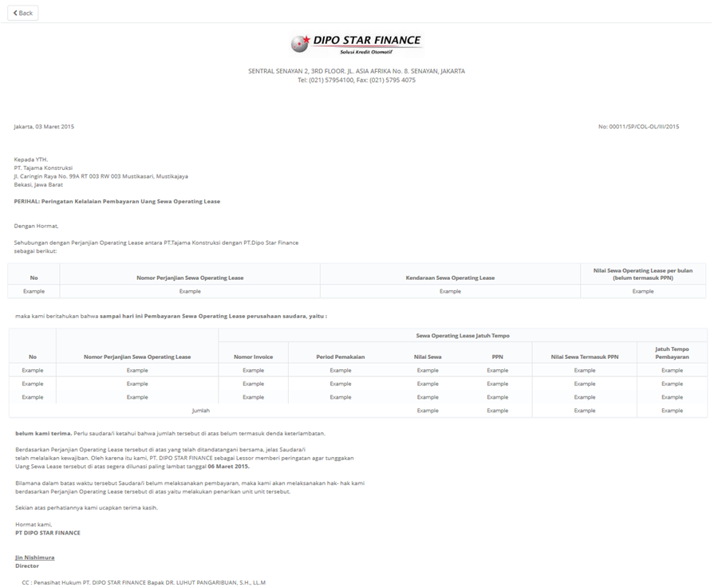

24

25

23

22

26

21

20

19

18

17

16

15

14

13

9

12

11

10

8

5

7

6

4

3

2

1

**RPT.AE.1.4 Warning Letter History**

|  |  |  |  |  |
| --- | --- | --- | --- | --- |
| *No.* | *Content* | *Description* | *Source* | *Remarks* |
| 1 | Warning Letter History Monthly Report | Default label | Static |  |
| 2 | Period | Period monthly report | Based on selected Start Date and End Date that already select by User when print Report | Format display report:  MM/dd/yyyy |
| 3 | Page | Number of Report Page | Automatically count by number of page | &[page] of &[total page] |
| 4 | Printed By | Printed By | Sys.CurrentUser |  |
| 5 | Printed Date | Printed Date | Use date at server when button Print Report is clicked | Format display report:  MM/dd/yyyy |
| 6 | DSF Office | Branch Short Name | TB\_OPL\_Branch.BranchShortName |  |
| 7 | Warning Letter Number | Warning Letter Number | TB\_BIL\_WarningLetter.WarningLetterNo |  |
| 8 | Agreement Number | Agreement Number | OPLAgreement.AgreementNumber | TB\_BIL\_WarningLetter.Tb\_BIL\_PayScheduleDetailID = TB\_BIL\_PayScheduleDetail.Tb\_BIL\_PayScheduleDetailID AND TB\_BIL\_PayScheduleDetail.Tb\_BIL\_PayScheduleID = TB\_BIL\_PaySchedule.Tb\_BIL\_PayScheduleID AND  TB\_BIL\_PayScheduleID.IdOPLAgreement = OPLAgreement.IdOPLAgreement |
| 9 | Overdue Bucket | Overdue Bucket | TB\_BIL\_WarningLetter.OverdueBucket |  |
| 10 | Overdue Days | Overdue Days | TB\_BIL\_WarningLetter.OverdueDays |  |
| 11 | Total Overdue | Total Overdue | TB\_BIL\_WarningLetter.TotalOverdue |  |
| 12 | Created By | Created By | TB\_BIL\_WarningLetter.CreatedBy |  |
| 13 | Warning Letter Issue Date | Warning Letter Issue Date | TB\_BIL\_WarningLetter.WarningLetterIssueDate | Format display report:  MM/dd/yyyy |
| 14 | Warning Letter Status | Warning Letter Status | TB\_BIL\_WarningLetter.WarningLetterStatus |  |

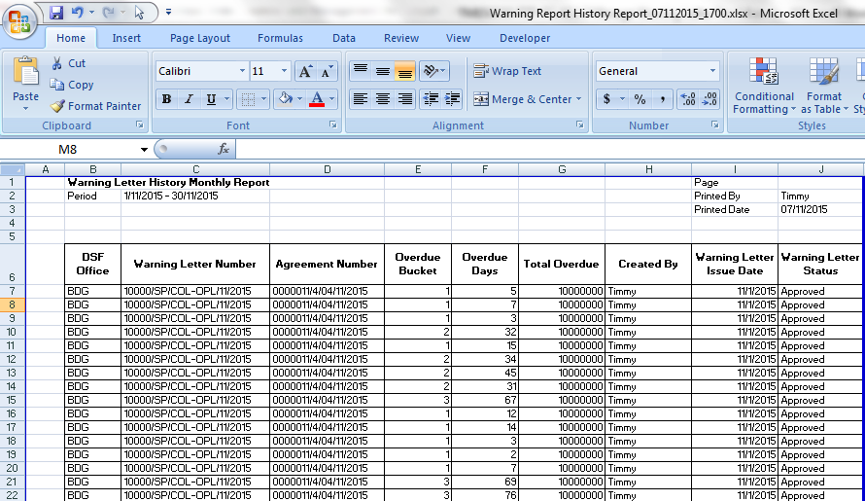

14

13

12

11

10

9

8

7

6

5

4

3

2

1

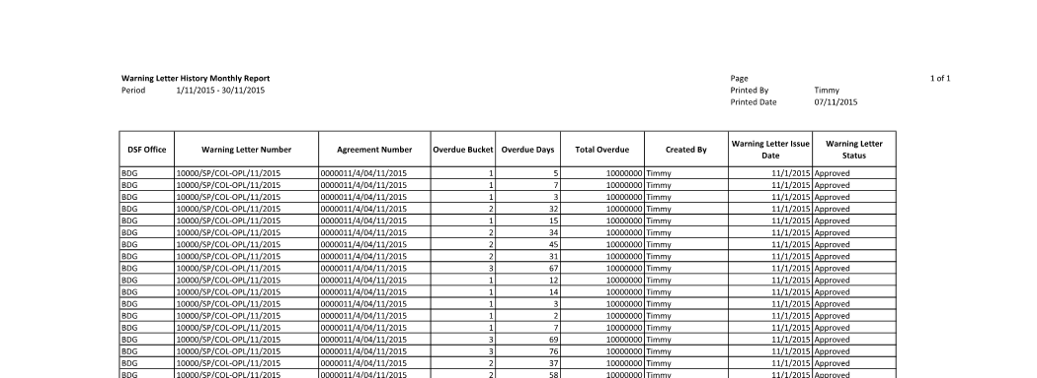

**Note:**

Content number 2, 3, 4, 5 and 6 will be page header format and will be printed in every page.

* 1. Entity Relationship Diagram

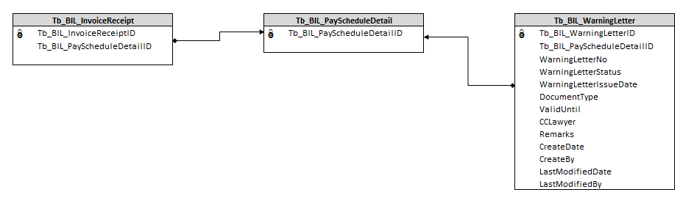

**APPENDIX**

Configuration Access for Manage Warning Letter:

|  |  |  |  |  |  |  |  |
| --- | --- | --- | --- | --- | --- | --- | --- |
| **User** | **Branch** | **Functions** | | | | | |
| **Display List** | **Create** | **Edit** | **View** | **Print Form** | **Print Report** |
| PIC Collection | One | V | V | V | V | V | V |
| Area |  |  |  |  |  |  |
| All |  |  |  |  |  |  |
| Head of Branch | One | V |  |  | V | V | V |
| Area |  |  |  |  |  |  |
| All |  |  |  |  |  |  |
| Head of Department | One |  |  |  |  |  |  |
| Area |  |  |  |  |  |  |
| All | V |  |  | V | V | V |
| Regional Manager | One |  |  |  |  |  |  |
| Area | V |  |  | V | V | V |
| All |  |  |  |  |  |  |
| Advisor | One |  |  |  |  |  |  |
| Area |  |  |  |  |  |  |
| All | V |  |  | V | V | V |
| Director | One |  |  |  |  |  |  |
| Area |  |  |  |  |  |  |
| All | V |  |  | V | V | V |
| President Director | One |  |  |  |  |  |  |
| Area |  |  |  |  |  |  |
| All | V |  |  | V | V | V |
| Shareholder's Meeting | One |  |  |  |  |  |  |
| Area |  |  |  |  |  |  |
| All | V |  |  | V | V | V |
|  |  |  |  |  |  |  |  |
| **Legend:** |  |  |  |  |  |  |  |
| V = Have the access |  |  |  |  |  |  |  |